Report of Mobile Robotics HW1
- Code
all.launch
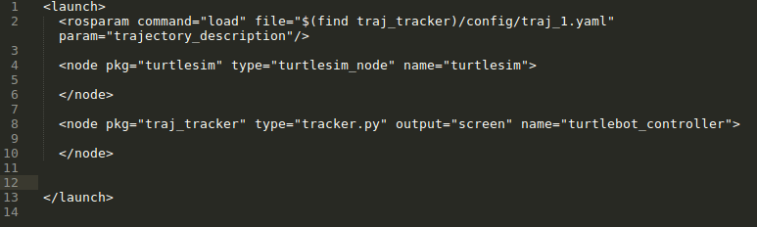
What I learned from the experience of writing a ROS launch file is: we should pay attention to setting the properties in node. I forgot to write “ output = “screen” ” so the node can’t print any information in terminal, which made a lot of difficulties for me to debug. I spent several hours to figure out what the problem is.

tracker.py
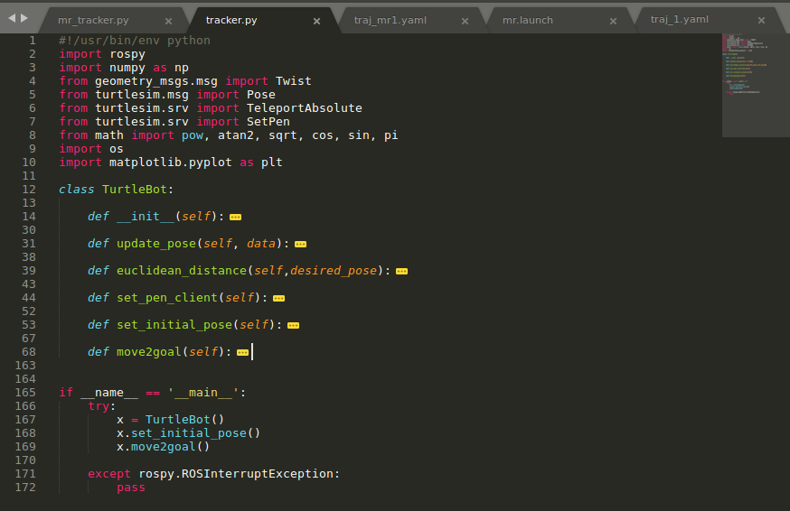
The “go to goal” Example really inspire me a lot, I used some of its function and defined new functions to achieve the requirement of the assignment. I designed a set_pen_client client function to send request to set_pen service and used a set_initial_pose client function to initialize my state.
In move2goal function, I used the control method told in the class to navigate the turtle to follow the desired trajectory and called set_pen_client to change colors.

- Result
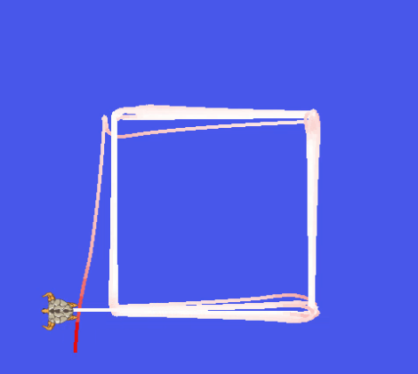
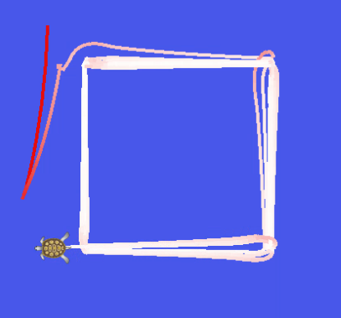
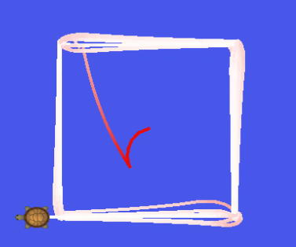
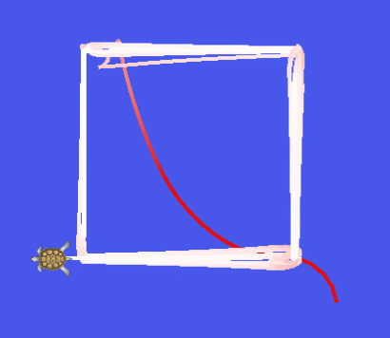
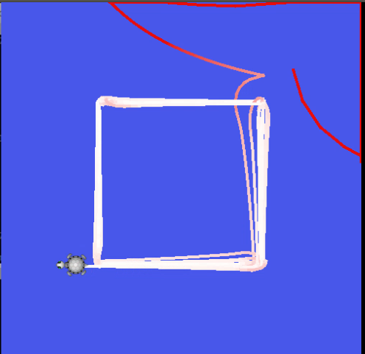

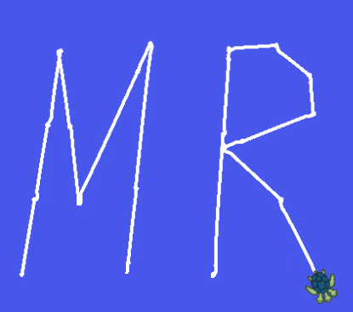
The images above are printed with the controller parameters of “sigma = 1.7, a = 3.2”, while
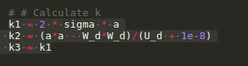
I think if I take more time to adjust my controller parameters, I can get a better result. The trajectories I got now have some drifts. Not a perfect result but I tried to do my best.
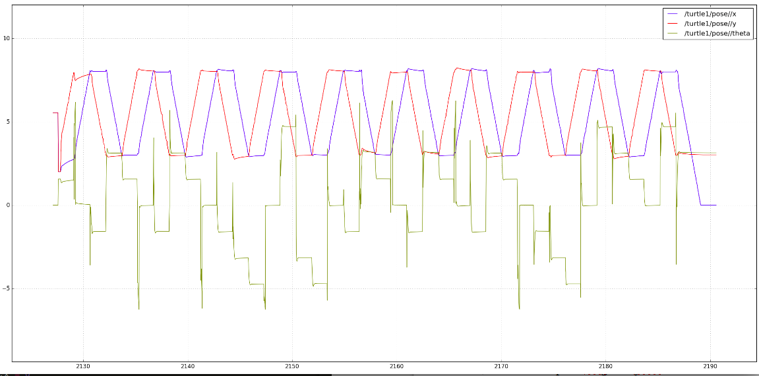
The figure above is one of the plotting figure. I used rqt_plot to plot the robot configuration (x, y, θ) vs time, that’s really convenient.

- Bouns
The method I applied to do this is:
1, rosrun turtle_teleop_key, use key to navigate the turtle to draw “M” and “R” letters.
2, Use rosbag to record the msg from /turtle1/pose topic
3, Convert the pose msg to a yaml file.
4, Use tracker node to follow the desired “MR” trajectory.

- Summery
I learned a lot from this assignment. It’s very interesting!
Now I have a basic idea about ROS, and I know how to write python and ros scripts.

